
SRM Institute of Science and Technology
Ramapuram campus
Department of Mathematics
18MAB101T – Calculus and Linear Algebra

Year/Sem: I/I Part – A Branch: Common to All
Unit – V
Sequence and Series
1. | A sequence is said to be convergent if | 1 Mark
1. | (a) (b)  (c) (d) | Ans (a) | (CLO 5, Remember)
2. | The sequence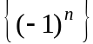 is | 1 Mark
 | (a) oscillatory (b) monotonic  (c) divergent to – ∞ (d) divergent to + ∞ | Ans (a) | (CLO 5, Remember)
3. | A sequence which is monotonic and bounded is | 1 Mark
 | (a) conditionally convergent (b) absolutely convergent  (c) convergent (d) divergent | Ans (c) | (CLO 5, Remember)
4. | The necessary condition for the convergence of is | 1 Mark
 | (a) (b)  (c) (d) | Ans (a) | (CLO 5, Remember)
5. | If and are two convergent sequences, then is | 1 Mark
 | (a) convergent (b) divergent  (c) oscillatory (d) neither convergent nor divergent | Ans (a) | (CLO 5, Remember)
6. | The geometric series converges if | 1 Mark
 | (a) (b)  (c) (d) | Ans (a) | (CLO 5, Remember)
7. | The series converges if | 1 Mark
 | (a) p > 0 (b) p < 1  (c) p > 1 (d) p ≤ 1 | Ans (c) | (CLO 5, Remember)
8. | The series diverges if | 1 Mark
 | (a) p > 0 (b) p < 1  (c) p > 1 (d) p ≤ 1 | Ans (d) | (CLO 5, Remember)
9. | If is a convergent series, then | 1 Mark
 | (a) 1 (b) ± 1  (c) 0 (d) ∞ | Ans (c) | (CLO 5, Remember)
10. | According to D’ Alembert’s ratio test, if is a series of positive terms and , then converges if | 1 Mark
 | (a) (b)  (c) (d) | Ans (a) | (CLO 5, Remember)
11. | By Cauchy’s root test, if is a series of positive terms and , then converges if | 1 Mark
 | (a) (b)  (c) (d) | Ans (a) | (CLO 5, Remember)
12. | By Raabe’s test, if 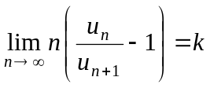, then diverges if | 1 Mark
 | (a) (b)  (c) (d) | Ans (a) | (CLO 5, Remember)
13. | By Logarithmic test, if 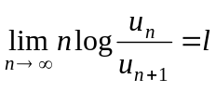, then converges if | 1 Mark
 | (a) (b)  (c) (d) | Ans (b) | (CLO 5, Remember)
14. | The series containing positive and negative terms is _________, if is divergent but is convergent. | 1 Mark
 | (a) divergent (b) oscillating finitely  (c) oscillating infinitely (d) conditionally convergent | Ans (d) | (CLO 5, Remember)
15. | The series containing positive and negative terms is absolutely convergent, if is | 1 Mark
 | (a) convergent (b) divergent to – ∞  (c) divergent to + ∞ (d) oscillatory | Ans (a) | (CLO 5, Remember)
16. | Every absolutely convergent series is necessarily | 1 Mark
 | (a) divergent (b) convergent  (c) oscillatory (d) conditionally convergent | Ans (b) | (CLO 5, Remember)
17. | The series 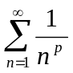 is convergent if | 1 Mark
 | (a) p = 0 (b) p =1  (c) p > 1 (d) p < 1 | Ans (c) | (CLO 5, Remember)
18. | As per D’ Alembert’s ratio test, if 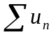 is a series of positive terms and 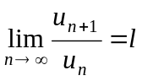, then the series is divergent if | 1 Mark
 | (a) = 0 (b) =1  (c) > 1 (d) < 1 | Ans (c) | (CLO 5, Remember)
19. | A series of positive terms cannot ___________. | - Mark
 | (a) oscillate (b) absolutely converge  (c) converge (d) diverge | Ans (a) | (CLO 5, Remember)
20. | The series 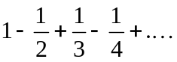is | 1 Mark
 | (a) divergent  (b) conditionally convergent  (c) oscillatory  (d) neither convergent nor divergent | Ans (b) | (CLO 5, Apply)
21. | The series 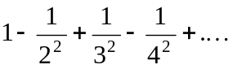is | 1 Mark
21. | (a) divergent  (b) absolutely convergent  (c) oscillatory  (d) neither convergent nor divergent | Ans (b) | (CLO 5, Apply)
22. | By Raabe’s test, if , then converges if | 1 Mark
22. | (a) (b)  (c) (d) | Ans (b) | (CLO 5, Remember)
23. | By Cauchy’s root test, if is a series of positive terms and , then diverges if | 1 Mark
23. | (a) (b)  (c) (d) | Ans (b) | (CLO 5, Remember)
24. | By Logarithmic test, if , then diverges if | 1 Mark
24. | (a) (b)  (c) (d) | Ans (a) | (CLO 5, Remember)
25. | If 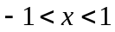, then the geometric series converges to | 1 Mark
25. | (a) 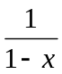 (b)  (c) 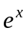 (d) 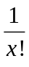 | Ans (a) | (CLO 5, Remember)
26. | The geometric series oscillates finitely if | 1 Mark
26. | (a) 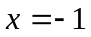 (b)  (c) (d) | Ans (a) | (CLO 5, Remember)
27. | The geometric series oscillates infinitely if | 1 Mark
27. | (a) 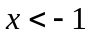 (b)  (c) (d) | Ans (a) | (CLO 5, Remember)
28. | If 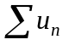is convergent, then (where k is constant) is | 1 Mark
28. | (a) convergent (b) divergent  (c) oscillatory (d) neither convergent nor divergent | Ans (a) | (CLO 5, Remember)
29. | The series is | 1 Mark
29. | (a) divergent (b) neither convergent nor divergent  (c) oscillatory (d) conditionally convergent | Ans (d) | (CLO 5, Apply)
30. | The convergence of the series is tested by | 1 Mark
30. | (a) Ratio test (b) Raabe’s test  (c) Leibnitz test (d) Cauchy Root test | Ans (c) | (CLO 5, Remember)
31. | A monotonic increasing sequence which is not bounded above is _____. | 1 Mark
31. | (a) oscillatory (b) convergent  (c) divergent to – ∞ (d) divergent to + ∞ | Ans (d) | (CLO 5, Remember)
32. | A monotonic decreasing sequence which is not bounded below is _____. | 1 Mark
32. | (a) oscillatory (b) convergent  (c) divergent to – ∞ (d) divergent to + ∞ | Ans (c) | (CLO 5, Remember)
33. | The series of positive terms is convergent if | 1 Mark
33. | (a) 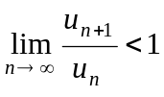 (b) 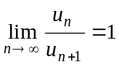  (c) 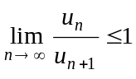 (d) 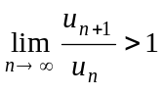 | Ans (a) | (CLO 5, Remember)
34. | The nth term of a series in Arithmetic Progression is | 1 Mark
34. | (a) 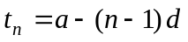 (b) 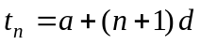  (c) 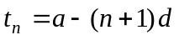 (d) 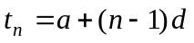 | Ans (d) | (CLO 5, Remember)
35. | 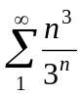is | 1 Mark
35. | (a) oscillatory (b) convergent  (c) divergent to – ∞ (d) divergent to + ∞ | Ans (b) | (CLO 5, Apply)
36. | The series 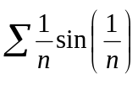is | 1 Mark
36. | (a) oscillatory (b) convergent  (c) divergent (d) conditionally convergent | Ans (b) | (CLO 5, Apply)
37. | If D’Alembert’s ratio test fails, then use | 1 Mark
 | (a) Comparison test (b) Leibnitz’s test  (c) Cauchy’s integral test (d) Raabe’s test | Ans (d) | (CLO 5, Remember)
38. | The series 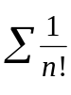is | 1 Mark
38. | (a) oscillatory (b) convergent  (c) divergent (d) conditionally convergent | Ans (b) | (CLO 5, Apply)

